Correct form

🡪with all the corrections

http://127.0.0.1:8000/trainee/trainee/

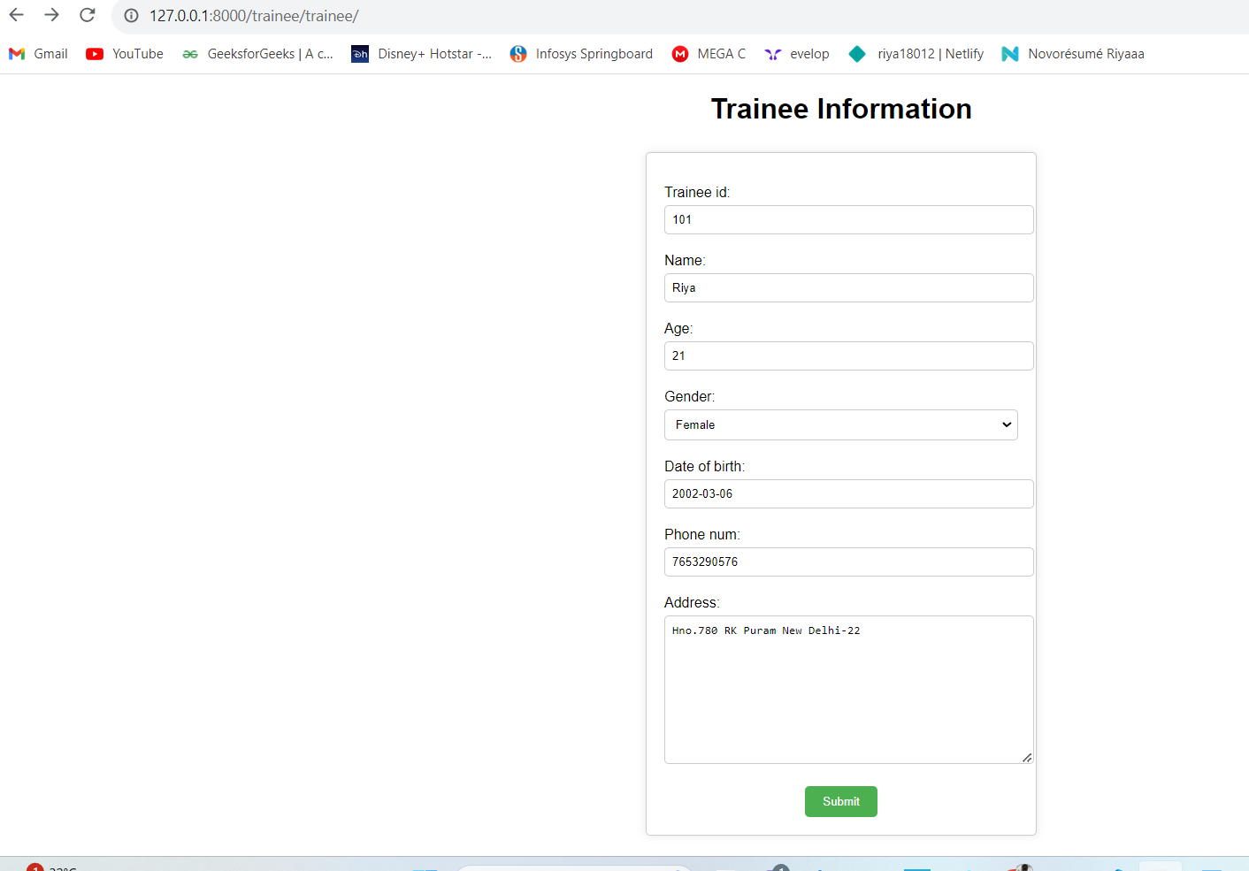

http://127.0.0.1:8000/trainee/success/

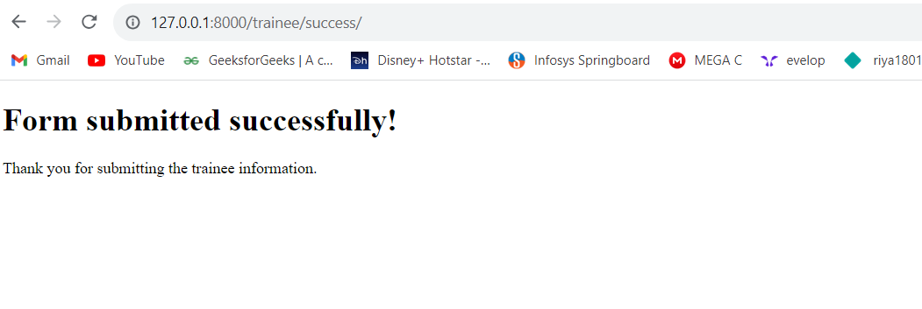

http://127.0.0.1:8000/admin/

